[ Insert official UPAEP logo ]
UPAEP · Decanato de Ingenierías
EVIDENCE — US14-T4
Test actuator status visualization
SmartGreenAI: Cilantro Crop

1. Task information
Task ID | US14-T4
User Story | US-14 — View actuator status
Sprint | Sprint 2 (2026-09-21 – 2026-10-09)
Week | Week 3
Responsible | Oscar Abraham Talavera Nava
Peer reviewer | Vicente Rocha Alfaro
Planned / actual hours | 1 h / 1 h
Completed on | October 8, 2026
Status | Done

2. Task description
Change an actuator state in the database and verify it appears on the panel; verify that an actuator without updates is shown as OFFLINE and that only logged-in users can see the panel.

3. Completion conditions
✓ Condition 1: State change in the DB appears on the panel.
How it was verified: The state of ACT-SHADE-01 was changed in the database (OFF → ON) and the panel showed the new state.
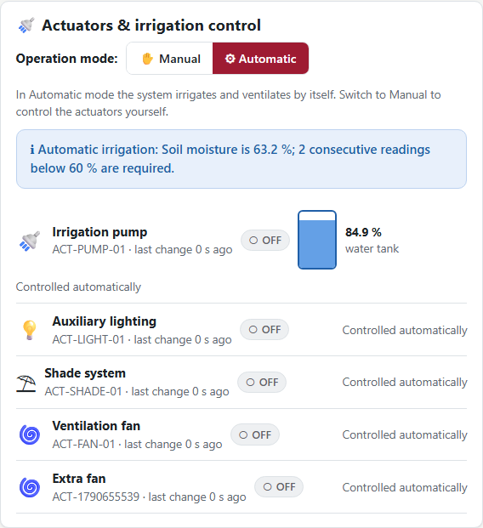
Figure US14-T4-1. Before: the shade system is OFF. (US14-T4_Test_Actuator_Status_Visualization_1.png)
State changed directly in the database (1 rows; US14-T4_Test_Actuator_Status_Visualization_2.csv)
id | state | last_update
ACT-SHADE-01 | ON | 2026-09-29T04:19:51.165Z
SQL: UPDATE actuators SET state = 'ON', last_update = NOW() WHERE id = 'ACT-SHADE-01' RETURNING id, state, last_update
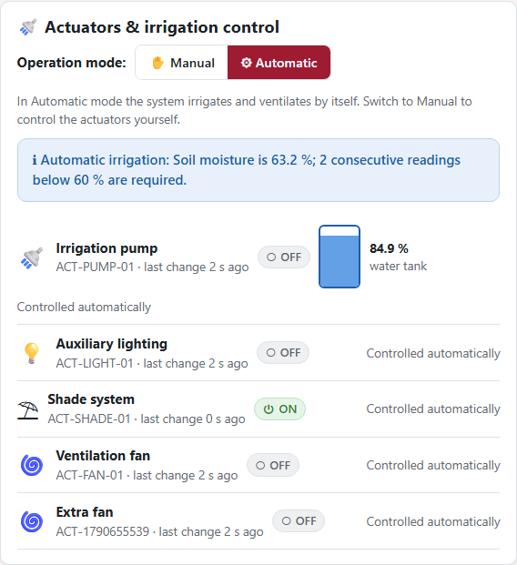
Figure US14-T4-2. After: the new state ON appears on the panel. (US14-T4_Test_Actuator_Status_Visualization_4.png)
✓ Condition 2: Actuator without recent updates appears as OFFLINE.
How it was verified: ACT-LIGHT-01 without updates for 10 minutes is shown as OFFLINE (API state "OFFLINE", reported_state "OFF").
Actuator without updates for 10 minutes (1 rows; US14-T4_Test_Actuator_Status_Visualization_5.csv)
id | state | last_update
ACT-LIGHT-01 | OFF | 2026-09-29T04:09:52.684Z
SQL: UPDATE actuators SET last_update = NOW() - INTERVAL '10 minutes' WHERE id = 'ACT-LIGHT-01' RETURNING id, state, last_update
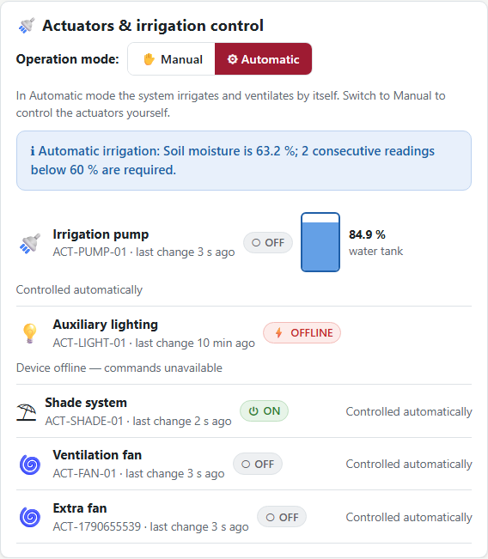
Figure US14-T4-3. The auxiliary lighting has not reported for 10 minutes and is shown as OFFLINE (commands disabled). (US14-T4_Test_Actuator_Status_Visualization_7.png)
✓ Condition 3: Only logged-in users can see the panel; screenshots saved.
How it was verified: Only logged-in users can see the panel: without a session the page redirects to login and the API answers 401. Screenshots saved.
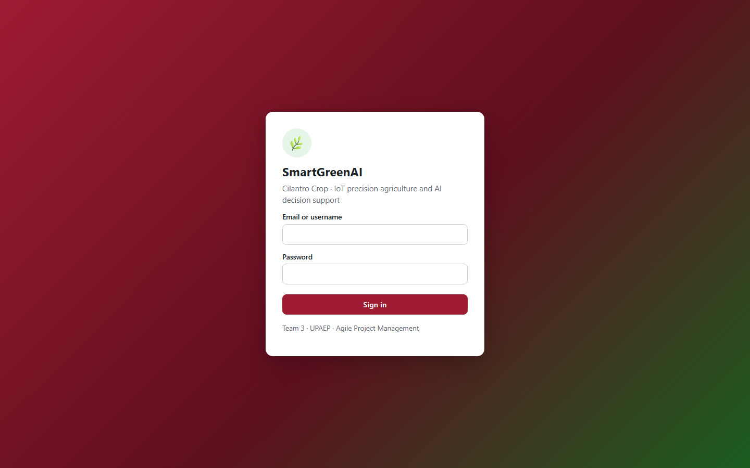
Figure US14-T4-4. Not logged in: the dashboard redirects to the login page, the panel is never shown. (US14-T4_Test_Actuator_Status_Visualization_8.png)
Status endpoint without a session (attached: US14-T4_Test_Actuator_Status_Visualization_9.txt)
GET /api/actuators/status
→ HTTP 401 Unauthorized (5 ms)
{
"status": 401,
"code": "ERR_AUTH_REQUIRED",
"message": "A Bearer token is required. Sign in to obtain one.",
"details": []
}

✓ Condition 4: Evidence: Test evidence with before/after screenshots.
How it was verified: Before/after screenshots and the test table are the evidence. The states were restored after the test.

4. Actuator status visualization tests
ID | Case | Steps | Input | Expected | Actual | Result
AS-01 | State change in the DB appears | UPDATE state = ON, reload the dashboard | ACT-SHADE-01 OFF → ON | panel shows ON | panel shows ON (Figure 2) | PASS
AS-02 | Actuator without recent updates | last_update = now − 10 min | ACT-LIGHT-01 | OFFLINE | API state OFFLINE; panel OFFLINE (Figure 3) | PASS
AS-03 | Anonymous user | Open /producer/ and GET /api/actuators/status without session | no token | login page; 401 | redirected to login; HTTP 401 | PASS
Totals: 3 cases · 3 PASS · 0 FAIL

5. Attached files
- US14-T4_Test_Actuator_Status_Visualization_1.png
- US14-T4_Test_Actuator_Status_Visualization_2.csv
- US14-T4_Test_Actuator_Status_Visualization_3.sql
- US14-T4_Test_Actuator_Status_Visualization_4.png
- US14-T4_Test_Actuator_Status_Visualization_5.csv
- US14-T4_Test_Actuator_Status_Visualization_6.sql
- US14-T4_Test_Actuator_Status_Visualization_7.png
- US14-T4_Test_Actuator_Status_Visualization_8.png
- US14-T4_Test_Actuator_Status_Visualization_9.txt

6. Traceability
Related requirements | FR-16, NFR-06
Implementation | See docs/TRACEABILITY.md
Verification | See docs/TRACEABILITY.md

7. Sign-off
Role | Name | Date | Signature
Responsible | Oscar Abraham Talavera Nava | October 8, 2026
Peer reviewer | Vicente Rocha Alfaro | October 8, 2026
Product Owner acceptance | Alexis Enrique Valle Parra | October 8, 2026

